**1.INTRODUTION**

Workers Employment is a project based on providing daily work for workers those who are searching for employment in the morning sessions roadside. This project is designed using Xampp server and Php language. The users simply need to register in the website and login. Then if someone has need of workers, they can login and post the same information by choosing the location of work area.

* 1. **Problem Statement**

The existing websites doesn’t provide affective communication between employee and service provider. It is a burden for workers to search for work on daily basis. Once in the morning session if he/she doesn’t get work then the whole day they should waste their time and they can’t earn money and livelihood maybe difficult for them to survive. This issue is being faced by many workers now-a-days.

Keeping this in mind, absence of best resources and weak support many failed to implement a website which provides the basic employment for daily labor. In view of this issue, we need to develop a website which will be helpful for workers who work on daily basis and earn money.

**1.2. Proposed System**

Our implementation of the website will be done in PHP language and using XAMPP sever. **XAMPP** is a [free and open-source](https://en.wikipedia.org/wiki/Free_and_open-source) [cross-platform](https://en.wikipedia.org/wiki/Cross-platform) [web server](https://en.wikipedia.org/wiki/Web_server) [solution stack](https://en.wikipedia.org/wiki/Solution_stack) package developed by Apache Friends, consisting mainly of the [Apache HTTP Server](https://en.wikipedia.org/wiki/Apache_HTTP_Server), [MariaDB](https://en.wikipedia.org/wiki/MariaDB) [database](https://en.wikipedia.org/wiki/Database), and [interpreters](https://en.wikipedia.org/wiki/Interpreter_(computing)) for scripts written in the [PHP](https://en.wikipedia.org/wiki/PHP) and [Perl](https://en.wikipedia.org/wiki/Perl) [programming languages](https://en.wikipedia.org/wiki/Programming_language). Since most actual web server deployments use the same components as XAMPP, it makes transitioning from a local test server to a live server possible.

In this website service provider can register and login to choose the area of work where he desires and can request for how many workers he need for that day. Accordingly, workers will be assigned to the service provider on daily basis by the admin.

Here admin will take care of maintaining the database and assigning the work to particular workers who already registered to the admin.

* 1. **Existing System**

In existing system customer is not allowed to contact or search for a worker directly, it is

done via a company, workers are also not paid according to their service companies takes

commission for assisting them. In proposed system customer is allowed to contact worker

directly without any mediators and workers are paid directly by the customer without any

cuts in their payment.

**2.SYSTEM REQUIREMENT SPECIFICATION**

**2.1 Hardware Requirements**

**Processors:**

Processor : Intel Pentium IV,2.4 GHz  
RAM : 512 MB  
Hard Disk Drive : 40 GB

**2.2 Software Requirements**

Operating System : Window XP, Windows 7  
Front –End : HTML, Java Script, PHP  
Back-End : PHP, MYSQL  
Supporting Server : Apache Tomcat 5.5, Xampp Server

**2.3 Tools and Technologies Used**

* Html
* Javascript
* PHP MyAdmin
* Python
* XAMPP server

**3. SYSTEM DESIGN**

**Worker**

**Employe**r

**ADMIN**

Admin

**WORKERS EMPLOY MENT**

Database Registration

Request for Workers Login

Selection of Location

Response

Response Through Email

**Fig-1**: Flowchart of workers employment

**4.IMPLEMENTATION**

**XAMPP:**

XAMPP is an open source software developed by [Apache friends](https://www.apachefriends.org/download.html). XAMPP software package contains Apache distributions for Apache server, MariaDB, PHP, and Perl. And it is basically a local host or a local server. This local server works on your own desktop or laptop computer. The use of XAMPP is to test the clients or your website before uploading it to the remote web server. This XAMPP server software gives you the suitable environment for testing MYSQL, PHP, Apache and Perl projects on the local computer.

The full form of XAMPP is X stands for Cross-platform, (A) Apache server, (M) MariaDB, (P) PHP and (P) Perl. The Cross-platform usually means that it can run on any computer with any operating system.

Next MariaDB is the most famous database server and it is developed by MYSQL team. PHP usually provides a space for web development. PHP is a server-side scripting language. And the last Perl is a programming language and is used to develop a web application.

The XAMPP installation process is very simple and fast. Once XAMPP is installed on your local computer it acts as a local server or localhost. You can test the websites before uploading it to the remote web server. This XAMPP server software gives you a suitable environment for testing MYSQL, PHP, Apache and Perl applications on a local computer.

**Working of XAMPP:**

Once XAMPP installation is completed you can start and stop each module by using **XAMPP Control Panel**. For example, testing PHP applications on your computer, you can start the two modules Apache and MySQL. It will allow PHP programs to run on your computer.  This XAMPP software emulates remote server like an environment on your local computer.

As an app developer, you need to test applications as many times as possible to find and fix the bugs. If you are testing in the local environment like XAMPP, it will speed up your development process.

Before XAMPP every time you need to upload files to a remote server for testing purpose. It will be quite difficult to test on the live server and it is visible to your visitors. But whereas in XAMPP you can easily test and make any updates in your localhost. At any number of times, you can update and test in XAMPP.  Once completed you can upload this new updated files to the remote server.

**Apache:**

Apache server is an open source free software which is initially developed by a group of software developers and now it is maintained by Apache software foundation. Apache HTTP is a remote server(computer) if someone request files, images or documents using their browser they will serve those files to clients using HTTP servers. Mainly hosting companies use this application to create a VPS server and shared hosting for their clients.

If you plan to move your testing website to web hosting, we recommend FastComet Cloud Hosting because they provide you the best service compared to other big companies. We have an Exclusive 50% Offer on [FastComet Coupon](https://www.wpblogx.com/fastcomet-coupon/) for our WPBlogX visitors.

[**MYSQL**](https://www.mysql.com/)**:**

MYSQL is an open source software. It is actually a relational database management system(RDBMS). This SQL stands for Structured Query Language. It is the most popular and best RDBMS used for developing a variety of web-based software applications. With the help of MYSQL, it is possible to organize the information, manage, retrieve and update the data whenever you wish to do.

[**PHP**](http://php.net/)**:**

The full form of PHP is Hypertext Preprocessor. It is a server-side scripting language that helps you to create dynamic websites. This language is mainly used to build web-based software applications. It is an open source software and works fine with MYSQL. What actually happens is, the PHP code will be executed on the server and at the browser side its HTML code will be displayed.

[**Perl**](https://www.perl.org/)

Perl is usually said to be the general purpose programming language. This Perl language is interpreted and highly dynamic. Actually, this language is used for web development, GUI development, system administration, etc. Perl is capable of working with HTML, XML and other markup languages.

In the latest version of XAMPP, there are additional tools such as Mail server Mercury, OpenSSL, phpMyAdmin, etc. With the above tools, you can create a full-fledged desktop server.

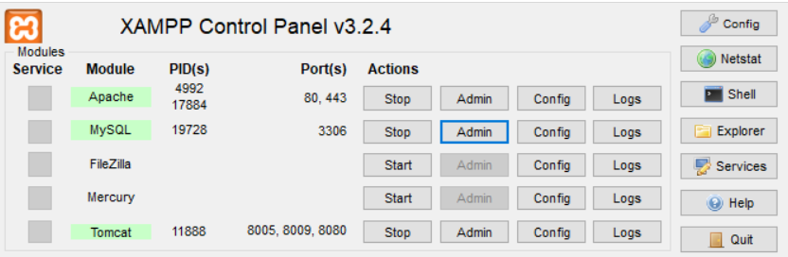

**Fig-2**: XAMPP server control panel

**5. TESTING AND RESULTS**

**5.1 RESULTS**



**Screen-1**: Home Page or Welcome Page



**Screen-2**: Contact page for more details of website

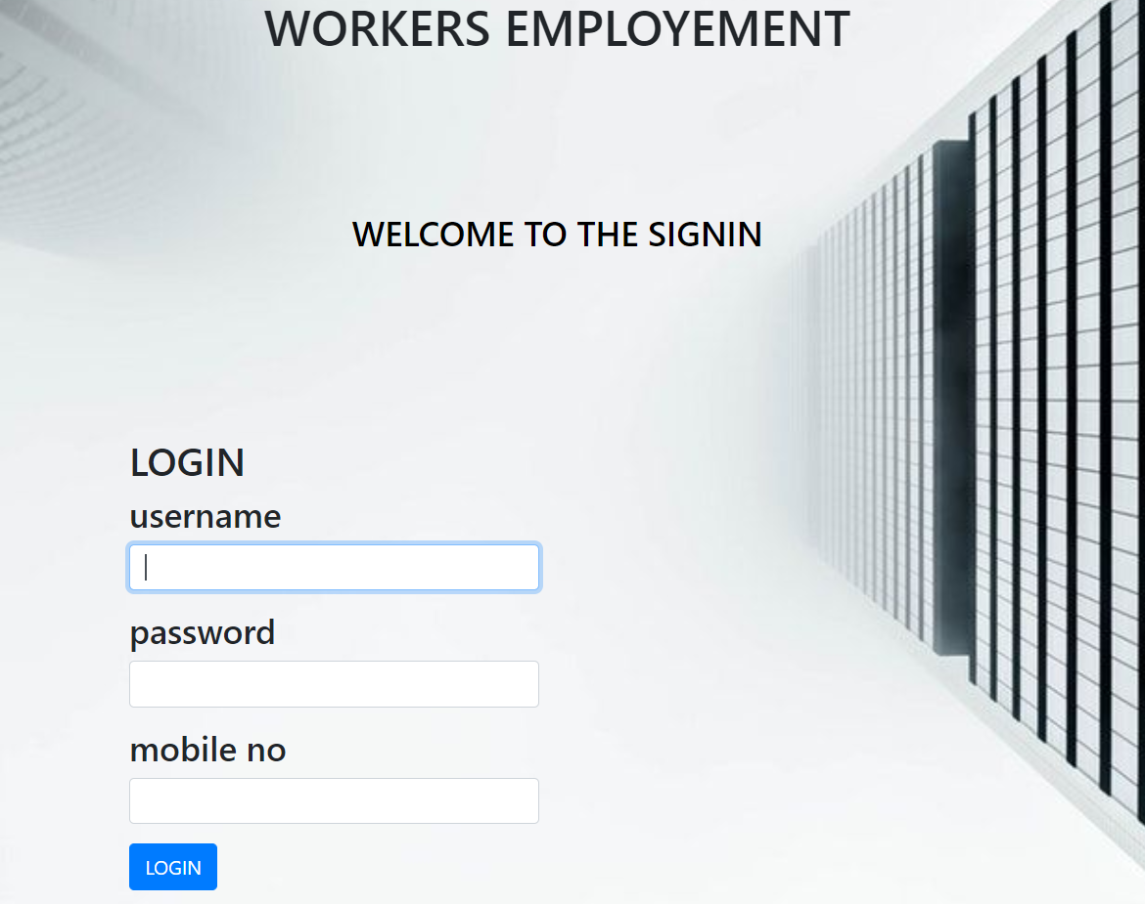

**Screen-3**: Sign in Page which appears when we click on enter for signup button in home page

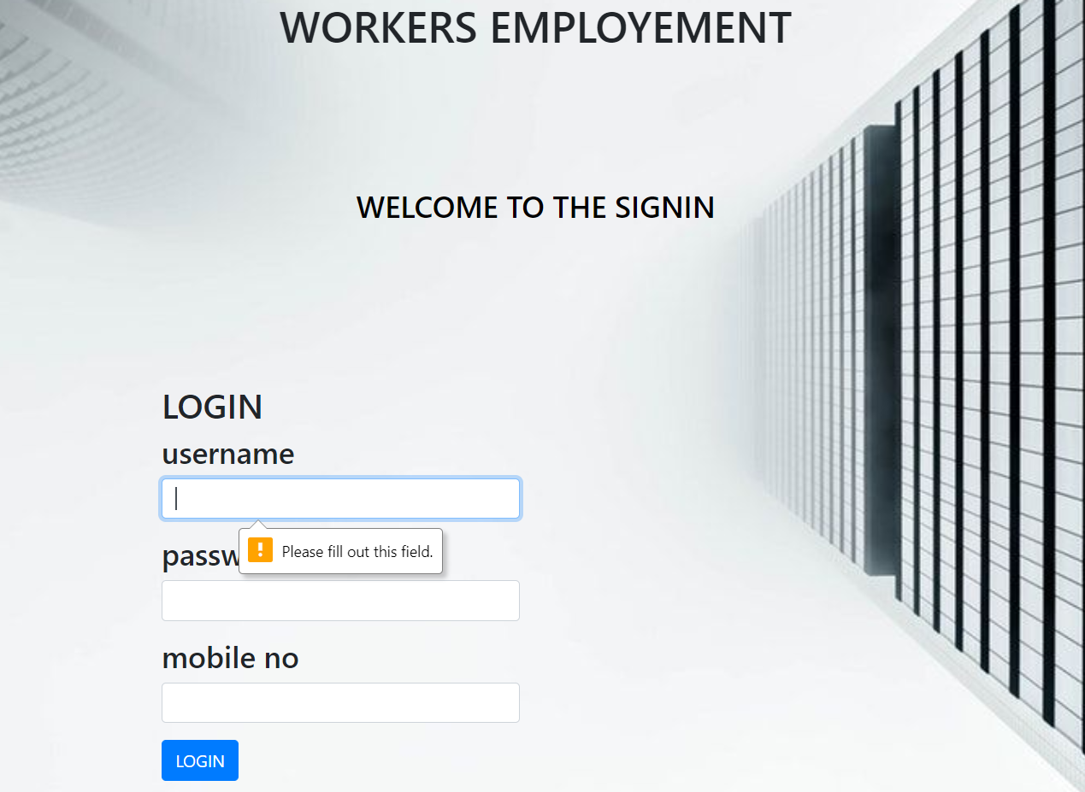

**Screen-4**illed: Error shown in signup page if nothing filled and tried to login



**Screen-5**: Error Page when user is not registered and made login

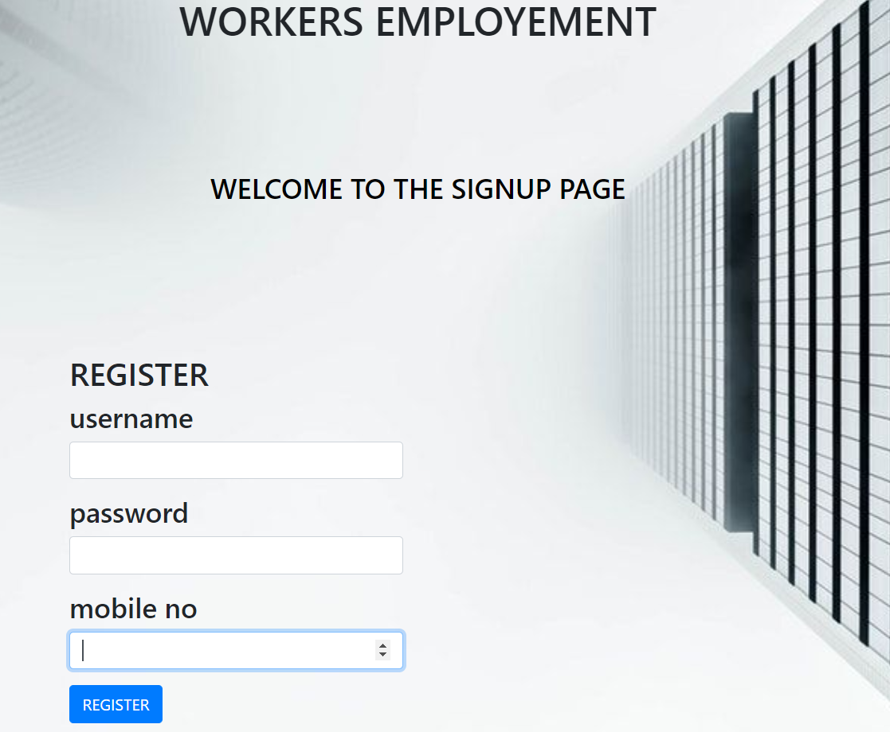

**Screen-6**: Registration Page or Signup page

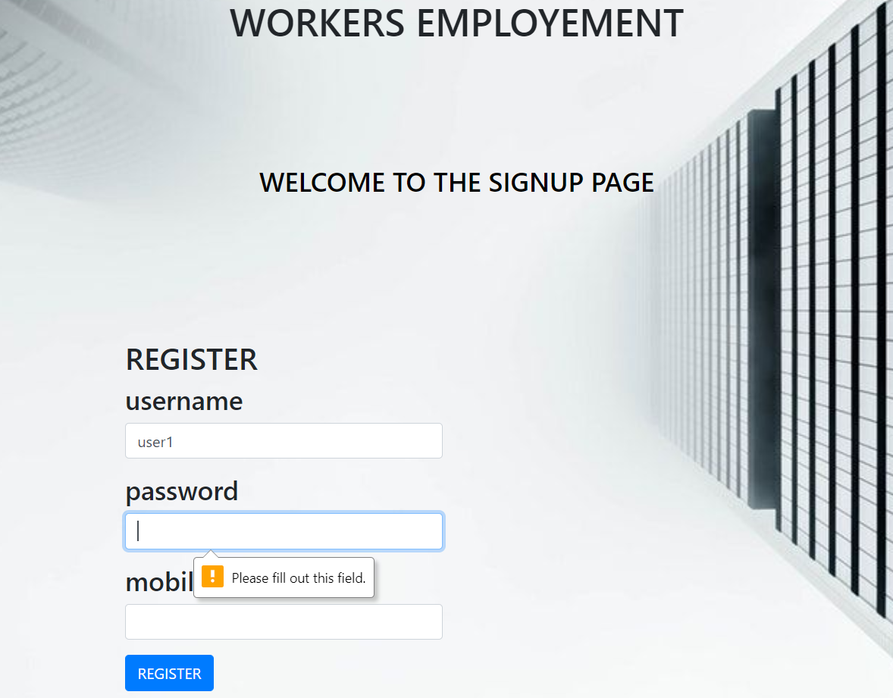

**Screen-7**: Error while registration if password is empty

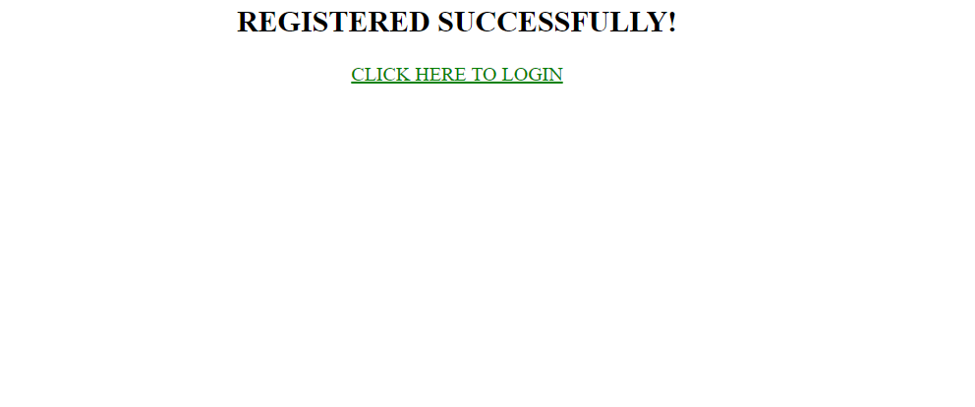

**Screen-8**: Page displayed if registration successful

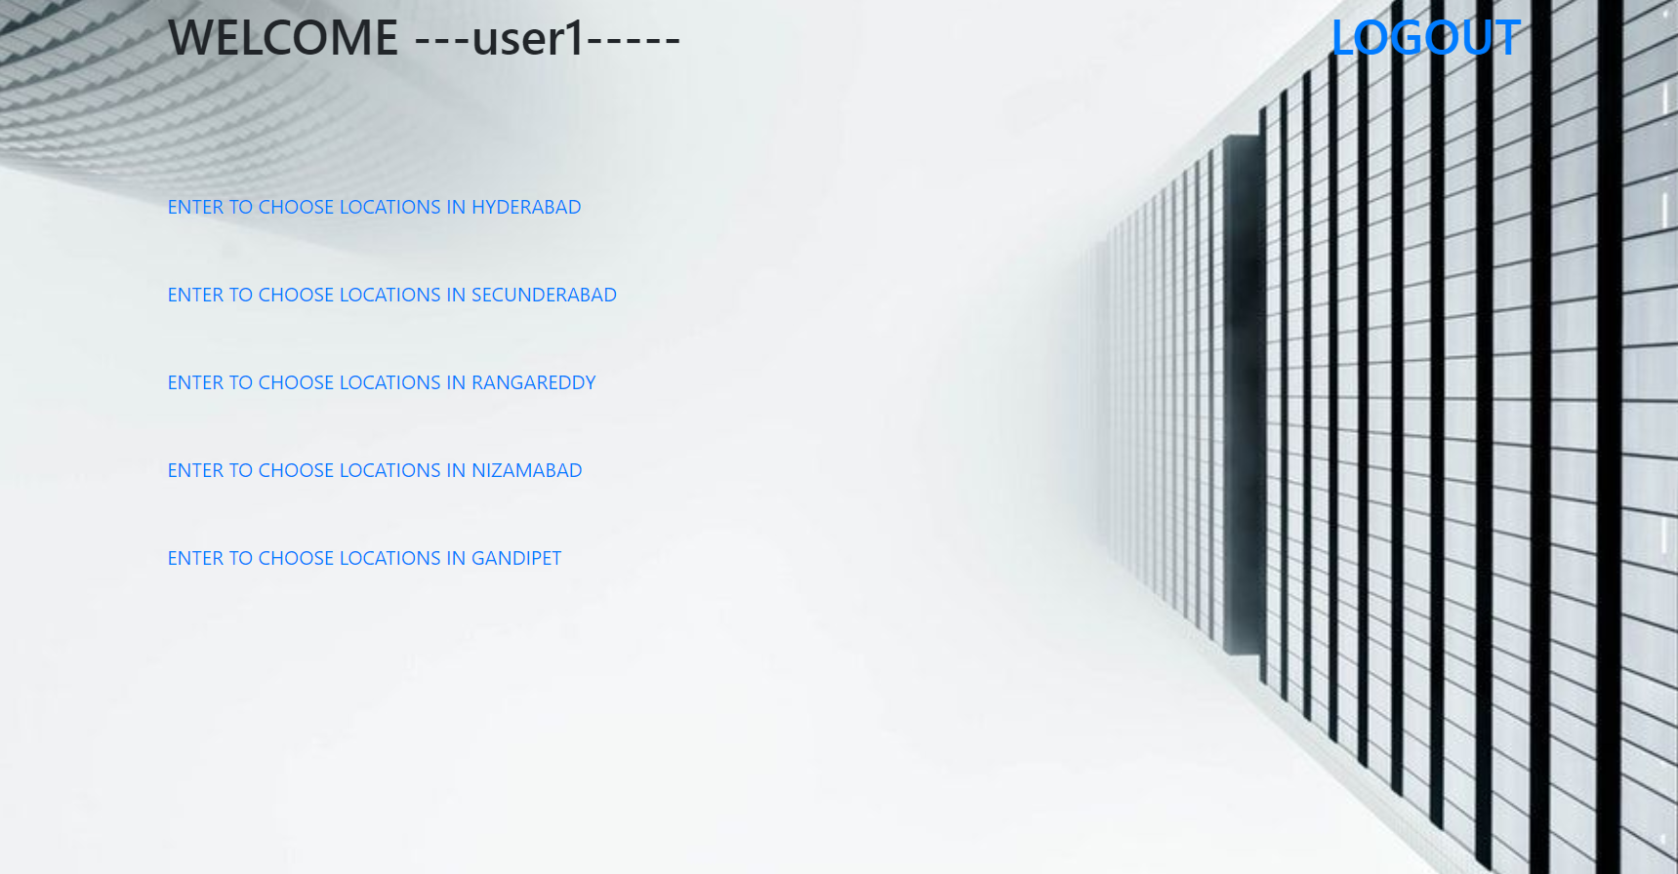

**Screen-9**: Locations of work



**Screen-10**: Selection of location of work

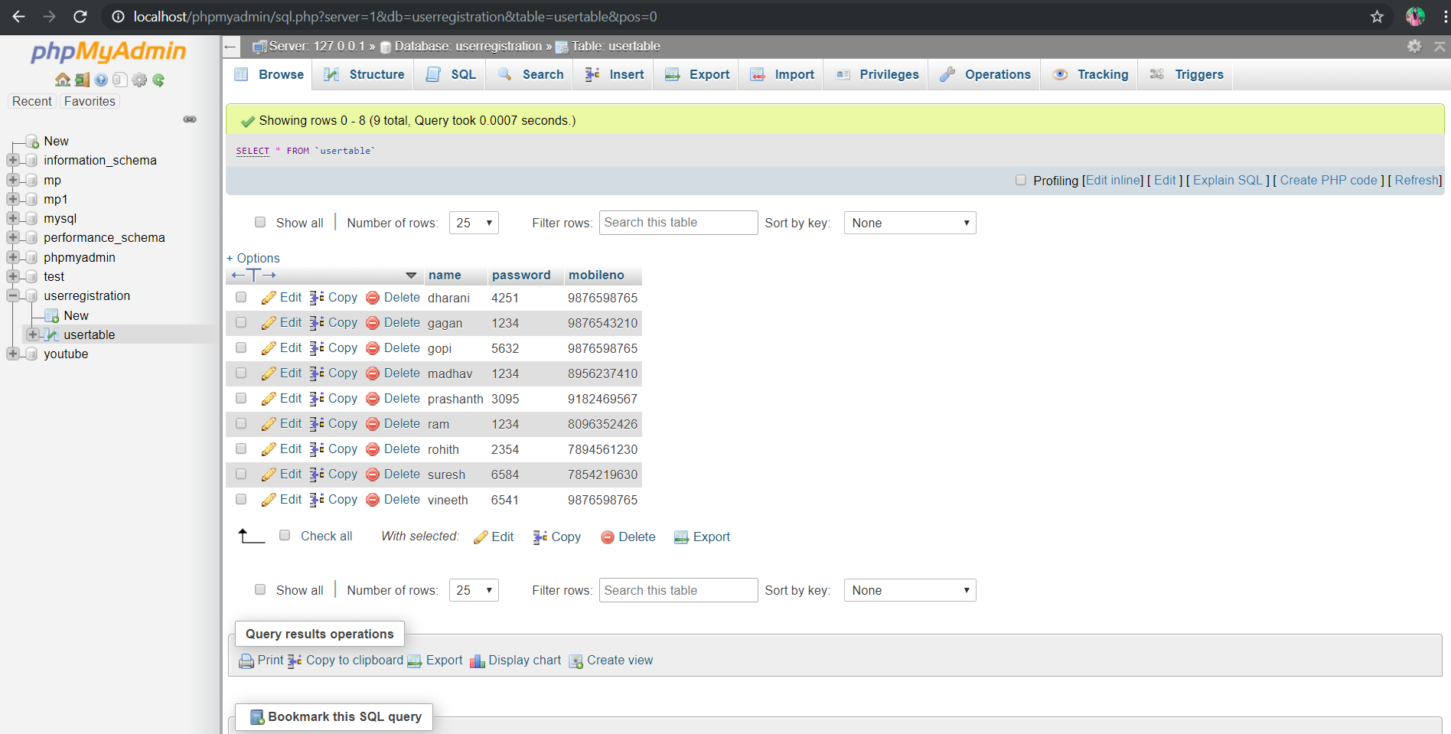

**Screen-1****1**: Storage of data in the backend

**6.CONCLUSION AND FUTURE SCOPE**

* This project basically developed mainly in the view of workers who work on daily basis.
* This can be implemented and developed across all forms of employment.
* Admin and worker interface shall be maintained for better progress of the website.
* In Future, By the end of the project ,we create a platform in between service provider and service receiver.
* And we can provide work for the workers**.**

**BIBLIOGRAPHY**

* <https://www.w3schools.com/>
* <https://www.apachefriends.org/download.html>
* <http://www.mytoptutorials.com/php/tag/xampp-tutorial/>
* <https://www.geeksforgeeks.org/php-program-fetch-data-localhost-server-database-using-xampp/>
* <http://tomcat.apache.org/>